STANDARD OPERATING PROCEDURE
Shellback Spin Rinser-Dryer

- SCOPE
The purpose of this document is to describe requirements and basic operating instructions for the Shellback Spin Rinser-Dryer. This tool is intended for cleaning wafers by rinsing with deionized water and subsequently drying under an inert nitrogen atmosphere in a single processing chamber.
- SAFETY
- Operation of the Spin Rinser-Dryer should be performed in ‘Process” mode.
- Only use wafer cassettes provided by AFNF that are specifically intended for SRD use.
- Ensure all substrates fit completely inside the designated cassette. Loose pieces or partial wafers are not permitted.
- No acids, bases and other solvents are allowed to use in the tool.
- Never run a process without a wafer cassette.
- Always wear clean gloves when operating the tool’s touch screen panel.
- Do not leave the equipment unattended during the process.
- APPLICABLE DOCUMENTS, MATERIALS AND REQUIREMENTS
- Please speak with the Staff if you need to use your own recipe.
- Ask AggieFab staff for complete manual of the system.

- TOOL OVERVIEW
- The system is configured to accommodate 76.2 mm, 100 mm, 150 mm, and 200 mm wafers.
- Rotors marked 0-25 means then can run 0-25 wafers. Do not load more wafers.
- If using wafers with flats, place them ‘up’ but will rotate during process.
- OPERATION
  - Select the appropriate SRD unit based on wafer size.
SRD 1
(Upper Unit): dedicated to 76.2 mm (3”) substrates.
(Lower Unit): dedicated to 200 mm (8”) substrates.
SRD 2
(Upper Unit): dedicated to 100 mm (4”) substrates.
(lower Unit): dedicated to 150 mm (6”) substrates.

  - Turn on iLab
  - An ‘Emergency Off’ alarm may be displayed.
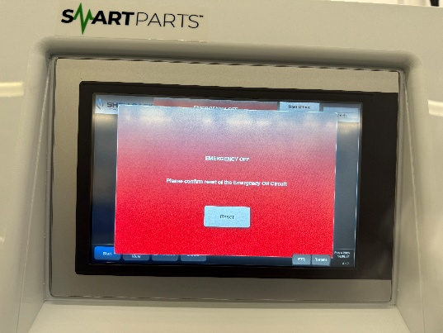
  - Click ‘Reset’
  - Log in using the credentials:
Username: Process
Password: process
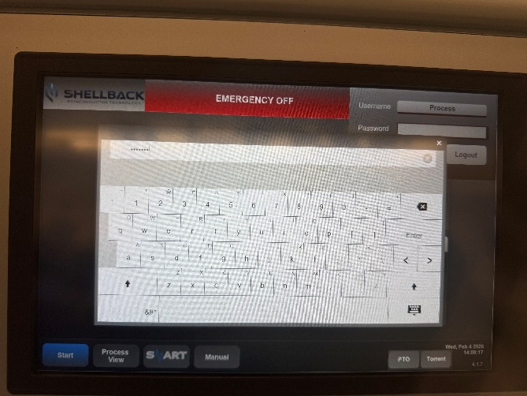
  - After logging in, navigate to the Alarms tab.
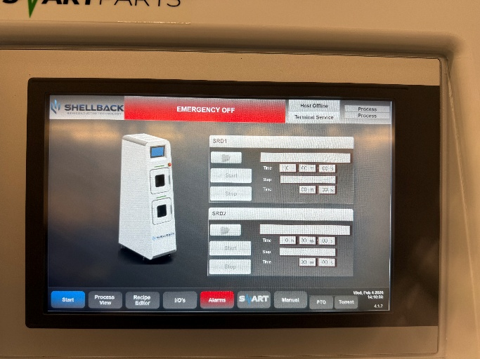
  - Click Reset to acknowledge and clear the alarm.
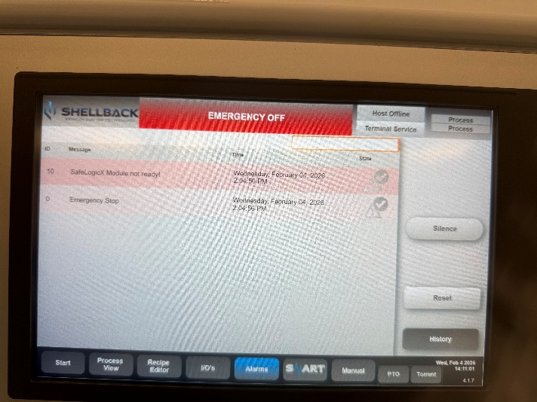

  - Navigate to the Process View tab once all alarms are cleared.
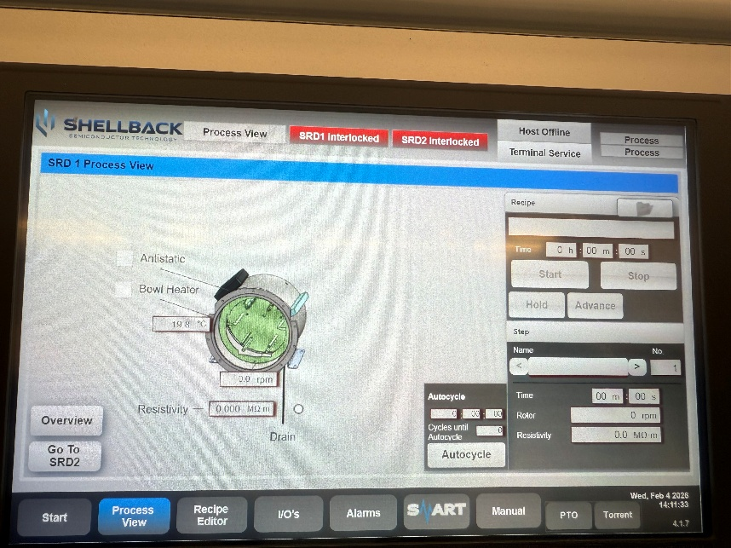
  - SRD 1 is the top chamber, and SRD 2 is the bottom chamber. Use the ‘Go To SRD 1/2' tab to navigate between SRD 1 and SRD 2 as required.
  - Load the wafers into the SRD chamber using the AFNF provided PTFE wafer cassette. Ensure wafers are placed evenly in the cassette for each chamber (best performance is achieved by loading 13 wafers evenly spaced throughout the cassette).
  - Make sure the H-bar faces the back of the chamber when you load the wafer cassette.
  - Close the chamber lid.
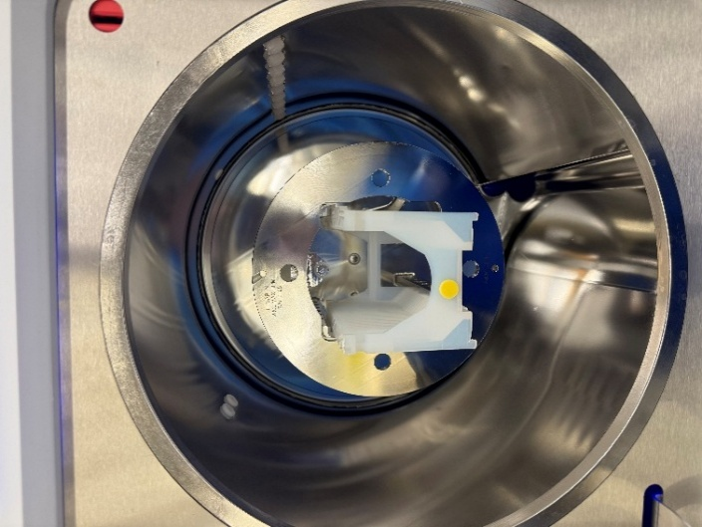
  - Touch the folder icon appeared right to the ‘Recipe’.
  - Select the ‘AFNF’ recipe.

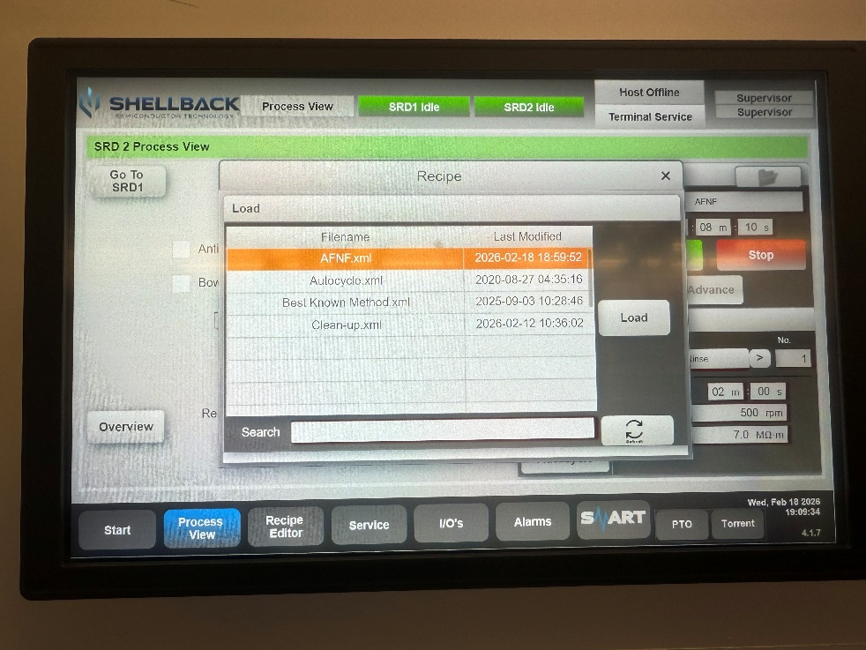

Details of AFNF recipe.
Steps | Time (hr:min:sec) | Rotor (rpm) | Resistivity (MOhm.m)
Rinse | 00:02:00 | 500 | 7
Purge | 00:00:10 | 1800 | 0
Dry 1 | 00:02:00 | 1800 | 0
Dry 2 | 00:04:00 | 500 | 0

  - Touch ‘Load’ to load the selected recipe.
  - Touch ‘start’ to initiate the process.

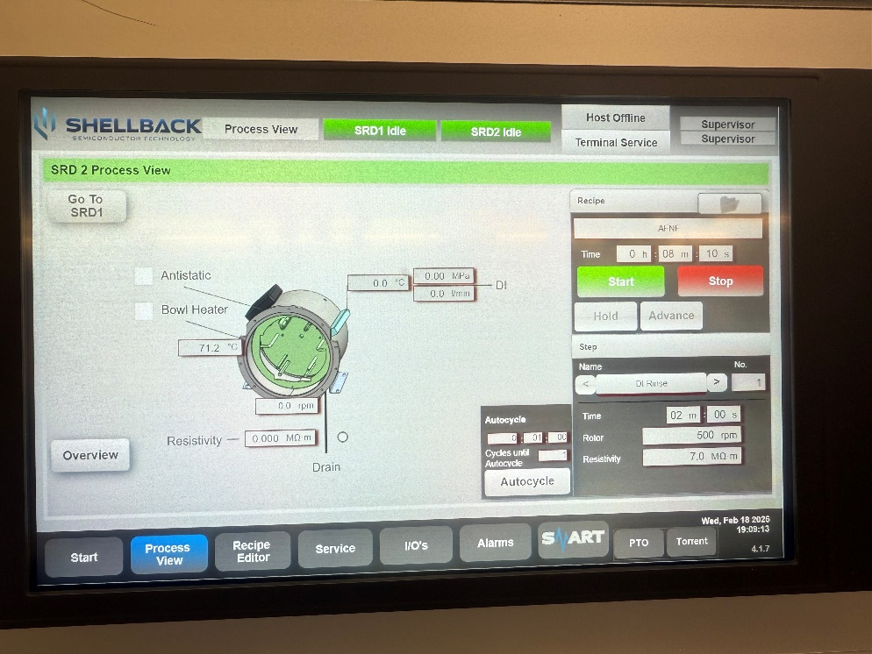

  - Look for the status light bar. When the tool is cycling, status light bar displays green light. In the event of any alarms, (it will be flashing red light), please let AFNF staff know about it.
  - After the cycling is done, please take the wafers out and keep the wafer cassette back into the chamber.

- SIGNATURES AND REVISION HISTORY
  - Author of this document: Rajasree Krishnan
    - Author Title or Role: Research Engineer
    - Date: 02/19/2026
    - Revision: Original Issue
    - Revision notes: Added standard procedure
  - Approvals:
Technical Manager Signature:__________Sandra Malhotra_______________

Date: ___________________02/19/2026______________________________

Revision History:
Revision | Author | Date
Original Issue | Rajasree Krishnan | 02/19/2026

